APQB Unit 5.2 – The Phillips Curve

Core Questions

1
- If the actual inflation rate is less than the expected inflation rate, which of the following must be true?
- There is an inflationary gap.
- The economy is in long-run equilibrium.
- Potential real output exceeds equilibrium real output.
- The cyclical rate of unemployment equals zero.
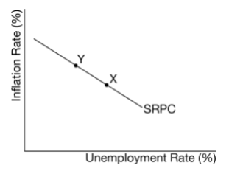
- The frictional rate of unemployment equals zero.

2

- Which of the following will cause a movement from point X to point Y along the short-run Phillips curve (SRPC) that is shown in the graph above?
- An increase the expected inflation rate
- An increase in the required reserve ratio
- An increase in government spending
- An increase in input costs
- An increase in inco\me taxes

3
- Use the graph below of the long-run Phillips curve (LRPC) and short-run Phillips curve (SRPC) to answer the question.
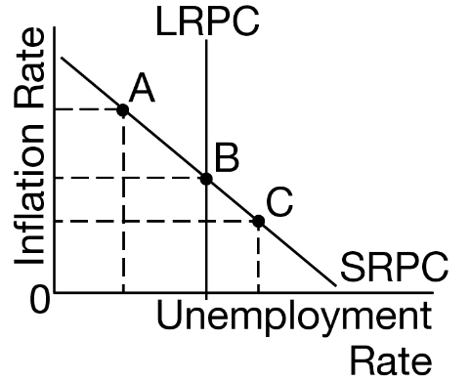
Assume members of the Organization of the Petroleum Exporting Countries (OPEC) agree to a coordinated increase in oil production. If the economy is at equilibrium at point B, what effect will this have on the Phillips curve model in the long run?
- The SRPC will shift to the left.
- The SRPC will shift to the right.
- The LRPC will shift to the right.
- There will be a movement from point B to point C.
- There will be a movement from point B to point A.

4
- Which of the following is true about the Phillips curve?
- A change in aggregate demand does not shift the long-run Phillips curve (LRPC).
- A change in aggregate demand does not cause a movement along the short-run Phillips curve (SRPC).
- The LRPC shows the trade-off between unemployment and inflation but the SRPC does not.
- Changes in expected inflation affect the LRPC only.
- Negative supply shocks affect the LRPC only.

5
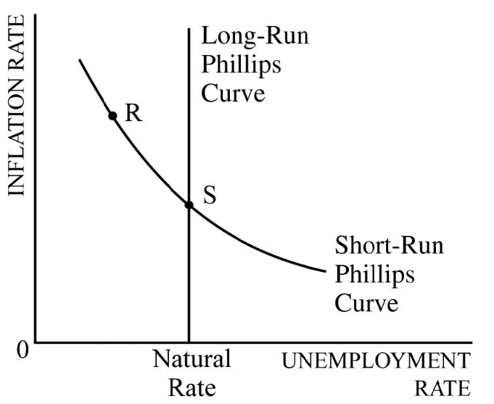 Which of the following would cause a movement from point S to point R on the short-run Phillips curve above?
- An unanticipated increase in government spending
- An unanticipated adverse supply shock
- A decrease in net investment
- An increase in real interest rates
- An increase in the labor-force participation rate

Answer
1 | c
2 | c
3 | A
4 | a
5 | A

